PROJECT REPORT

On

“ONLINE LIBRARY MANAGEMENT

SYSTEM”

Submitted by:

=>NALAM ANUNAY

=>P.V.D SAI KIRAN

ACKNOWLEDGEMENT

*The satisfaction that accompanies that the successful completion of any task would be incomplete without the mention of people whose ceaseless cooperation made it possible.*

*We are grateful to our project guide DR.Neetesh kumar sir.For the guidance ,inspiration and constructive suggestions that helpful us in preparing this project.*

*NALAM ANUNAY*

*(2019 BCS-034)*

*P.SAI KIRAN*

*(2019-BCS-037)*

ABSTRACT

*Library management system is a project which aims in developing a computerised system to maintain the daily work of library.*

*This Librarian after logging to his account can generate various options such as profile update ,insert books,issue book ,return books,updating fine status and also to respond to the posts In the complaint bar.*

*Any one can take Library membership by filling a Signup form and entering a code given by Librarian. A member can request at most for three books and his permission*

*to access a book in the library Is denied if he has any fine penalty due to late submission of book.*

*Member can post a complaint if the required book is not available or any other issue related to Library.*

*Over all this project is being done to help staff of library in the best possible way and also to reduce paper work and human efforts.*

TABLE OF CONTENTS

1.Description

2.Entity Relation Ship Diagram

3.Future Work and Scope

4.Conclusion

*Introduction:-*

*1.1 Purpose:-*

*The purpose of this application are as follows :*

*• The software is for automation of library.*

*• It helps to institute members to easily access the books in Library.*

*It reduces paper documents in the library*

*2.) Scope :The different areas where we can use this website are :*

*1) Any education institute can make use of it for providing information about author, content of the available books.*

*2) It can be used in offices and modifications can be easily done according to requirements.*

*3.) Technology Used :*

*Front End : HTML,CSS.*

*Back End : My sql, Apache Tomcat server,PHP.*

*4.) Assumptions*

*• User and librarian have to register only one phone number so that it is not multi valued.*

*5.) Overview : Project is related to library management which provides reading services to its members. Any student can become a member of the IIITMG library by filling a Sign_up form.*

*They can get the book issued, so that they can take home and return them.*

*6.) Functionality :*

*• Online membership.*

*• Keeps the track of issues and submission of books*

*ENTITY-RELATIONSHIP DIAGRAM:*



*Normalized Relational Schema Tables*

*Satisfies all conditions of 1NF,2NF,3NF,BCNF.*

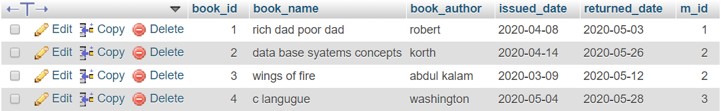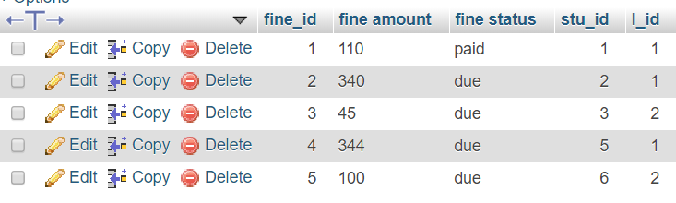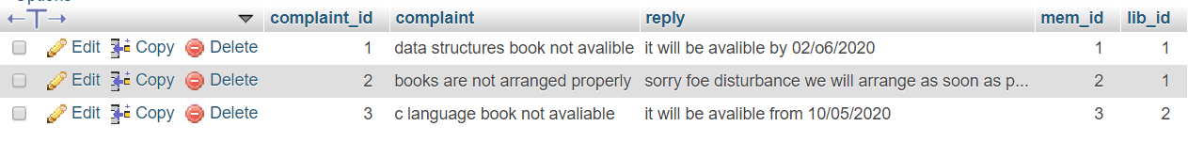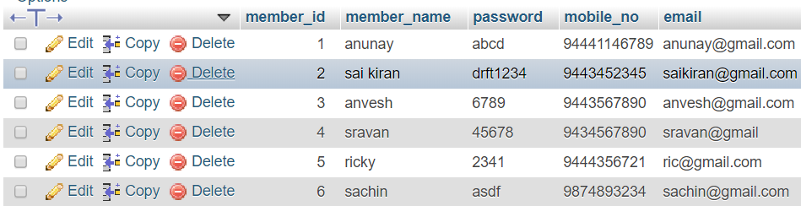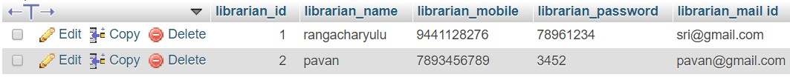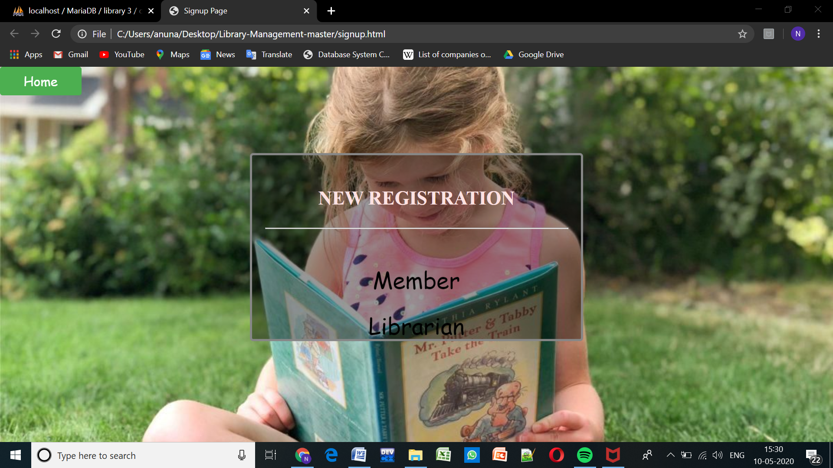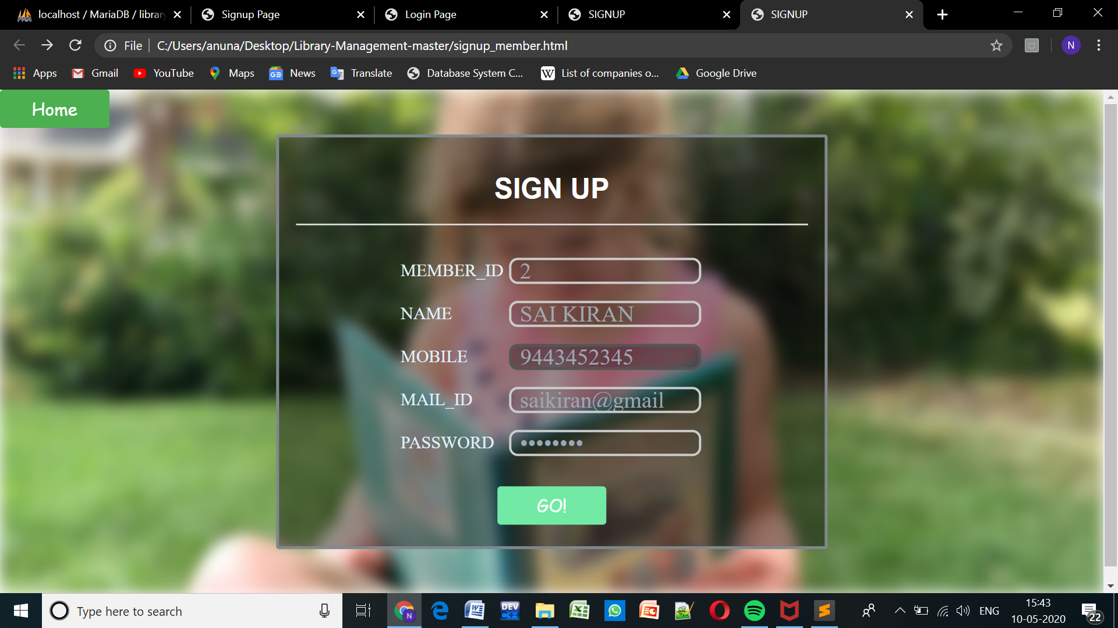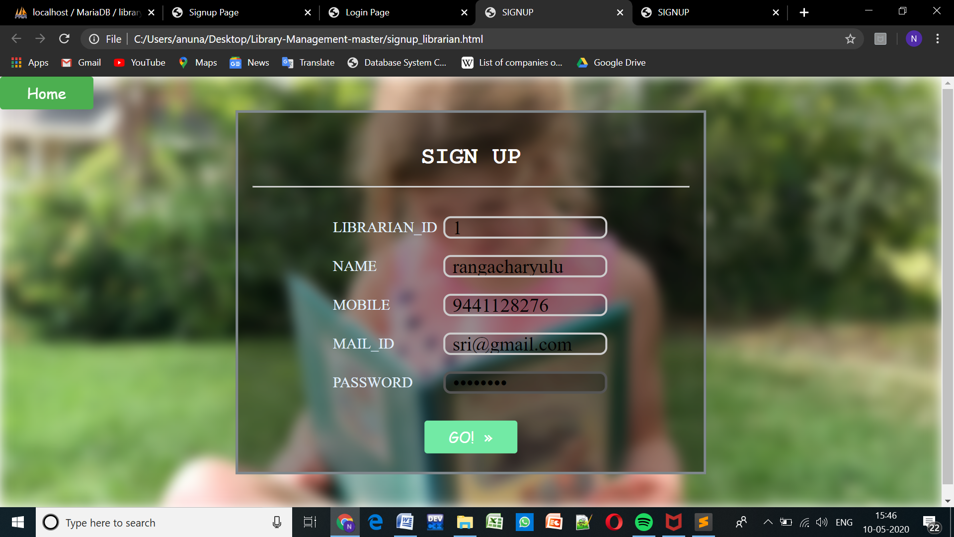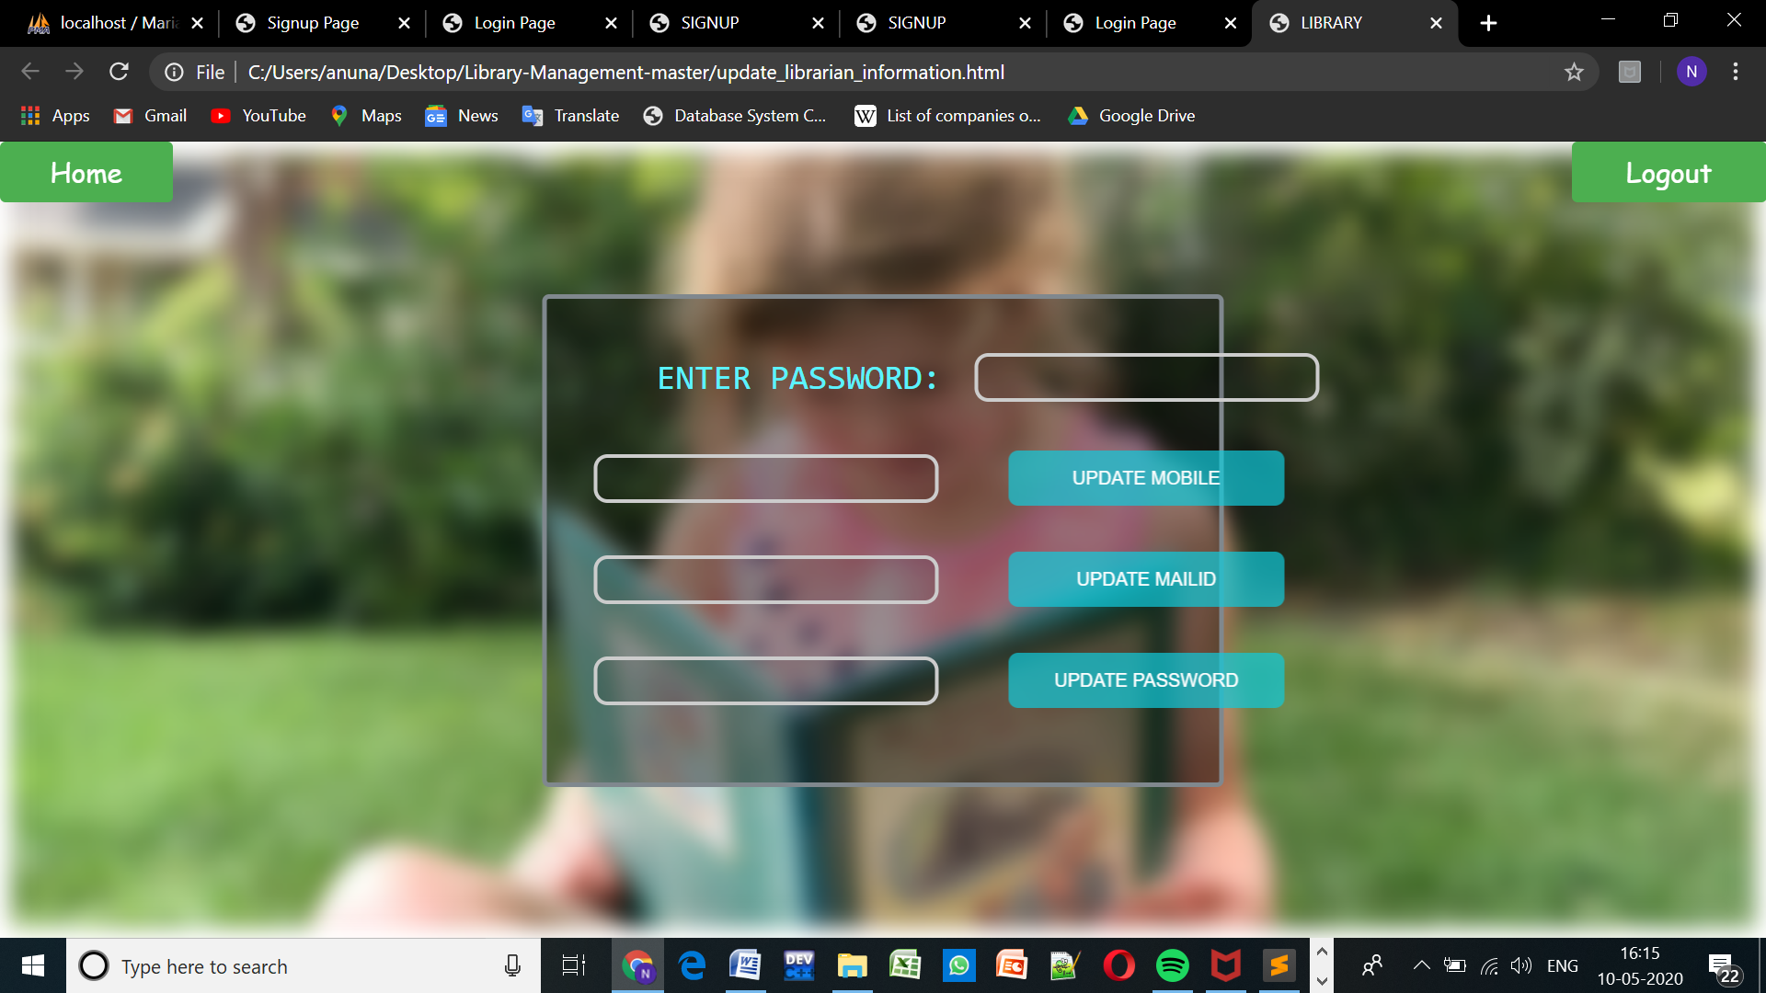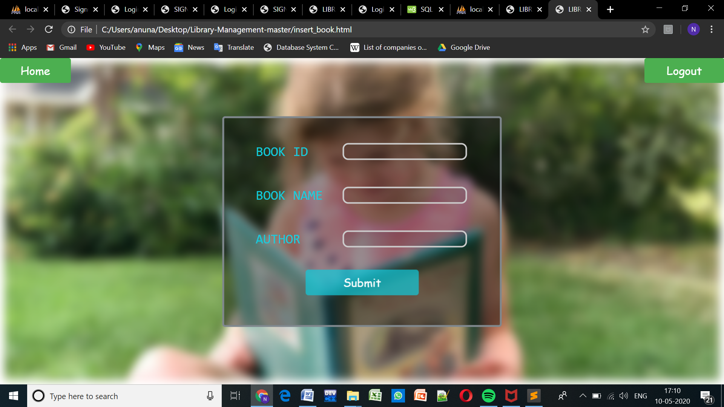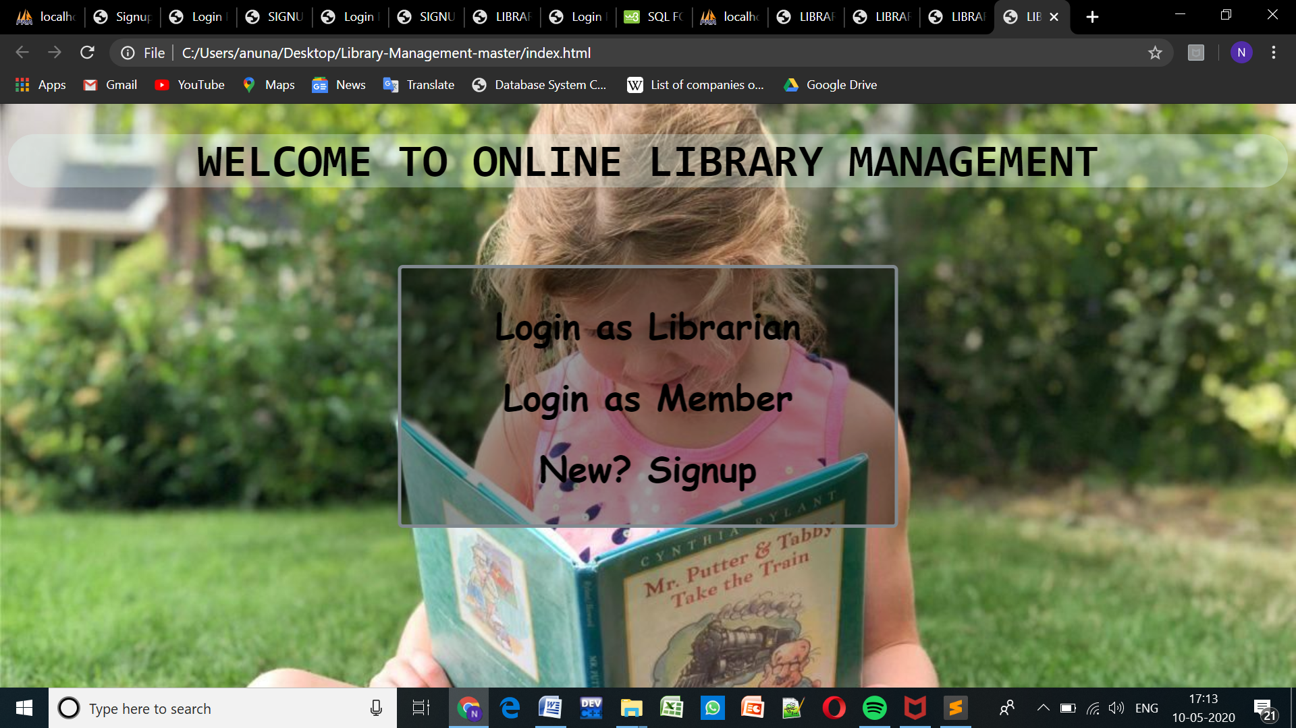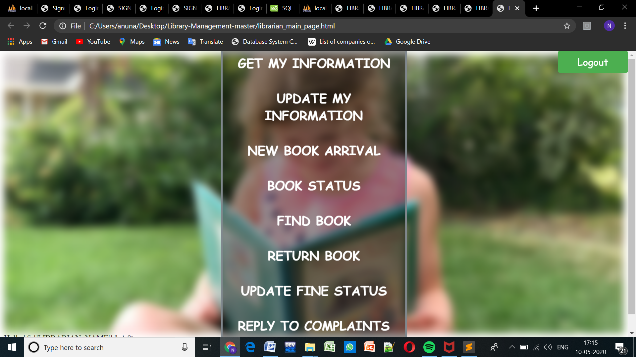

*SQL QUERIES*

*1)GIVE THE NAMES AND MOBILE NUMBER OF ALL THE*

*STUDENTS WHO REGISTERED IN LIBRARY*

*SELECT member_name,mobile_no*

*FROM member;*

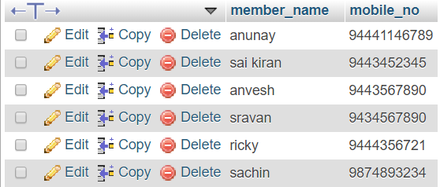

*2)NAME THE BOOKS INFORMATION TAKEN BY ANUNAY*

*SELECT book_id, book_name,book_author,issued_date,returned_date*

*FROM books*

*WHERE m_id=1;*

**

*2)NAME THE BOOKS INFOMATION TAKEN BY SAI KIRAN*

*SELECT book_id, book_name,book_author,issued_date,returned_date*

*FROM books*

*WHERE m_id=2;*

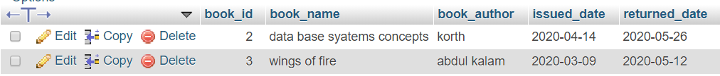

*3)STUDENT INFORMATION WHO DIDN’T PAY FEE*

*FUTURE SCOPE OF APPLICATION :*

*This website can be easily implemented under various college Libraries.*

*We can add new features as and when we require.*

*Conclusion:*

*From a proper analysis of positive points and constraints on the component, it can be safely concluded that the website is efficient and can be updated when needed*

*This application is working properly and meeting to all user requirements.*